Operating System Week-2

Name : Tanishq Vyas
SRN : PES1201800125
Section : H
Semester : 5
Branch : CSE

Exercise 1

# Script to print user information who currently login, current date & time
# Enter the following commands in a file
#
clear
echo "Hello $USER"
echo "Today is ";date
echo "Number of user login : " ; who | wc -l
echo "Calendar"
cal
exit 0

The file then is saved as exercise1.sh and the following command is executed in order to set permissions

$ chmod 775 exercise1.sh

Now, in order to execute we type

$ ./ exercise1.sh

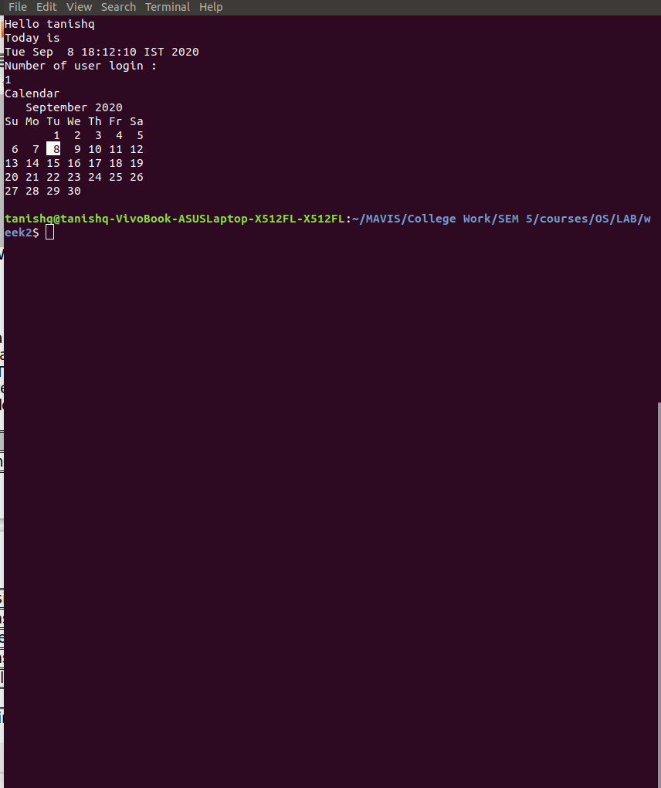

Exercise 2

1) If you want to print your home directory location then you give command:
a) echo $HOME
OR
(b)echo HOME
Which of the above command is correct & why?

Ans :
We use echo $HOME since it is a variable.

Exercise 3

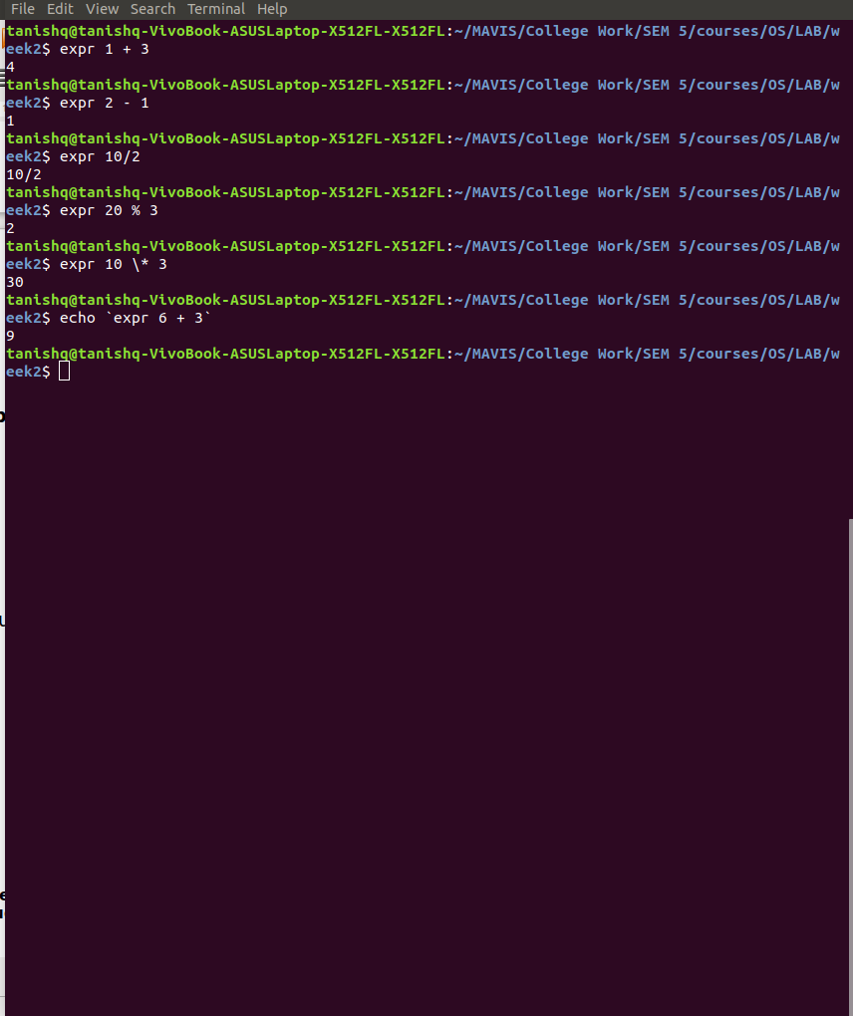

Exercise 4

1. Single quote : All special characters between these quotes lose their special meaning. Eg :

echo ‘$HOME’
outputs : $HOME

2. Double quote : Most special characters between these quotes lose their special meaning with these exceptions −

1) $
2) `
3) \$
4) \’
5) \”
6) \\

3. Back quote : Anything we write in between back quotes would be treated as a
command and therefore would be executed.

Exercise 5

$ sort < myfile > sorted_file

The above given command reads the input from the file named “myfile” (input redirection) and stores the sorted output (output redirection) in the file called sorted_file. In case any content is already present in the file, its over written.

Exercise 6

